Assignment 2 - COMP 249

Due Date: March 4th

Question: Part I

Written by: Augusto Mota Pinheiro (40208080)

Michaël Gugliandolo (40213419)

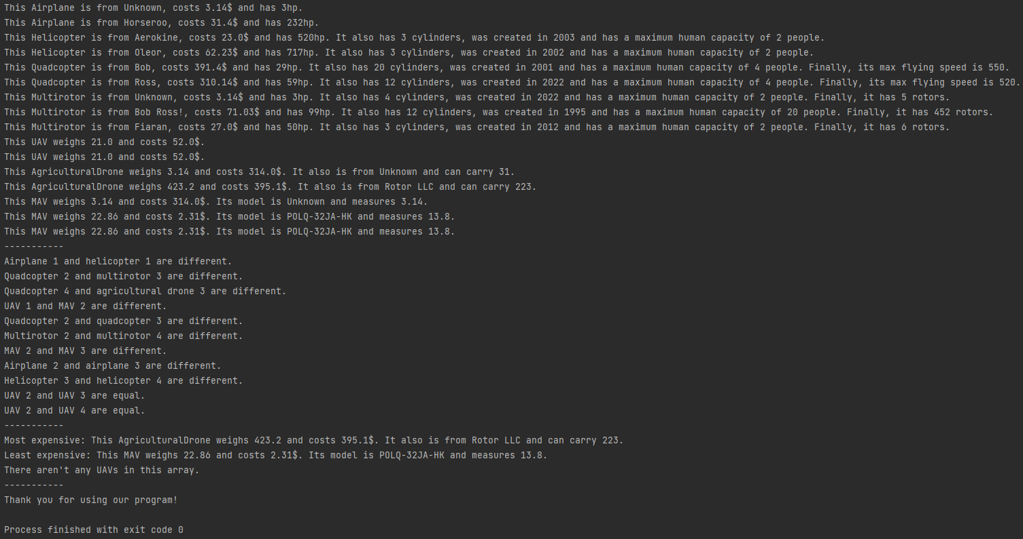

The toString methods from the flying objects print out the correct information. Also, the equals method to compare objects works perfectly; the only compared objects that are equal are UAV 2, 3 and 4, which is what’s shown in the output.

Furthermore, the findLeastAndMostExpensiveUAV method performed as expected. Out of the seven UAVs in the first array, we can see from the toString outputs that the highest price is 395.1$ and the lowest, 2.31$. Finally, since the second array doesn’t contain any UAVs, the method correctly informs us that there aren’t any UAVs.